Project Title
PLAN a change or improvement  The Problem  Aim/Goal  The goal of this project is to:  Team  DO the improvement, make the change  The Interventions  What changes did you make or plan to make? | STUDY the results and examine data  Graphs/Data  Or another supporting graphic. Compare where you started and what progress you have made since making changes.  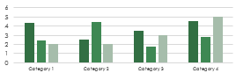  Lessons Learned  State key accomplishments achieved to date and lessons learned from working on this project.  ACT to sustain performance and spread change  Next Steps  Determine if need to expand to other areas or rework the cycle.

